**HUMANITIES CONNECTIONS TO LITERATURE**

|  |
| --- |
| **HUMAITIONS CONNECTION ASSIGNMENT PART 1**  While the events of *March: Book 1* are not fictional, the way the story is told, both narratively and visually, is in the literary style used in fiction. This allows for the opportunity to tell a story in a powerful and emotional way.  In Humanities classes we use more traditional nonfiction approaches to texts. This gives a broader view of events and tries to be more objective in its approach, though all texts are subject to some degree of bias. Both types of texts are important. When we know the larger historical context, it can enhance our appreciation of books we read that have a basis in history. March: Book 1 opens with an event that occurred on the Edmund Pettus Bridge in Selma, Alabama. The article below discusses the events that occurred on that day.  When reading about historic events, non-fiction can provide additional historic context or background evidence that can enhance your understanding of the story. Read the article below and answer the guiding questions provided. |

# **A Bridge in Selma**

# 

# By 1965, many activists believed the Civil Rights Act of 1964 was incomplete. Across the South, local white officials continued to prevent black citizens from registering to vote. To highlight this continuing problem, the Southern Christian Leadership Conference (SCLC) decided to focus on the city of Selma, Alabama. Selma's sheriff Jim Clark had developed an aggressive campaign of voter harassment. His deputies regularly bullied, beat, or arrested black people trying to enter the courthouse to register.

In January 1965, the Rev. Dr. Martin Luther King Jr. and other civil rights leaders met in Selma. They staged a series of nonviolent marches to draw national attention to the city's abuses. Time and again, Clark's men harassed and arrested the marchers, among them schoolchildren and King himself. Then the SCLC proposed a new strategy: a march to the state capitol in Montgomery--about 50 miles away--to present its case to Governor George Wallace. Learning of the march, Wallace warned against it.

|  |
| --- |
| 1. **Why was the Civil Rights Act in 1964 not effective in Selma, Alabama?** 2. **What was the purpose of the march?** |

On Sunday, March 7, 600 marchers set out from Brown’s Chapel in Selma. Leading the march were the SCLC's Hosea Williams and the Student Nonviolent Coordinating Committee (SNCC)'s John Lewis. The activists started across the Edmund Pettus Bridge and reached its crest. Lewis later described what they saw: "There, facing us at the bottom of the other side, stood a sea of blue-helmeted, blue-uniformed Alabama state troopers." Local deputies on horseback also had been called in. An officer ordered the marchers to disperse. Then another order was issued: "Troopers, advance!"

"The troopers and posse men swept forward," Lewis wrote, "a blur of blue shirts and billy clubs and whips...And then they were upon us. The first of the troopers...swung his club against the left side of my head." Next, "a cloud of smoke rose all around us. Tear gas. I began choking, coughing."

Dozens of marchers were knocked to the ground and half-trampled underfoot. Swinging their nightsticks, deputies on horseback charged into the rest. They pursued the marchers back across the bridge to the chapel, clubbing many as they ran.

|  |
| --- |
| 1. **How is the graphic novel’s depiction of this event similar and different to the article description?** |

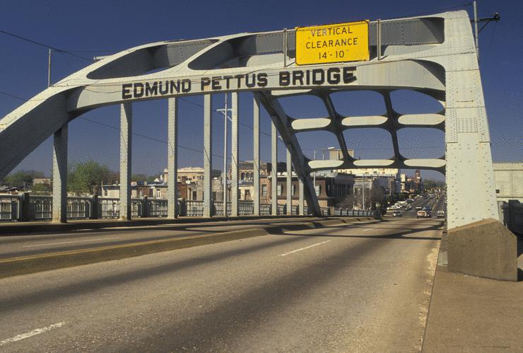

Americans were outraged. The brutality they witnessed on television became known as "Bloody Sunday." King and the rest of the activists planned a second symbolic march for the following Tuesday. Meanwhile, the SCLC asked a federal court judge to order the governor not to interfere. This time, there was no violence as the marchers turned back on their own accord. But that night, white men in Selma attacked three white ministers involved in the march. One of the ministers died. Public anger soared.

President Lyndon B. Johnson stepped in and ordered aid for the marchers. On Sunday, March 21, about 3,200 marchers set out escorted by Alabama National Guard troops, 2,000 U.S. Army soldiers, and federal agents.

By the time the marchers reached Montgomery four days later, their number had swelled to 25,000. In a speech on the capitol steps, King told the marchers, "They told us we wouldn't get here....But all the world today knows that we are here." Then King and a small delegation presented their petition to Wallace's office. In many ways it was a fitting location to end a civil rights march--Montgomery had been were the modern movement began with a boycott of its buses.

|  |
| --- |
| 1. **Would you consider the outcome of this March a success? Why or why not?** 2. **Why do you think John Lewis chose to open his book with scenes from this moment?** |