**HUMANITIES CONNECTIONS TO LITERATURE**

|  |
| --- |
| **HUMANITIES CONNECTION ASSIGNMENT PART 2**  Primary sources are the building blocks of history — original documents and objects that were created at the time under study. They are different from secondary sources, accounts that retell, analyze, or interpret events after the fact. Studying primary sources can give you a deeper understanding of the events. It is important to analyze each one to consider where the source came from, what part of the story it tells, and in what ways that sources might be useful in helping us understand what happened.  Analyze the following primary sources related to events from *They Called Us the Enemy* by answering the questions below. |

**Document 1: “I am an American” Photograph, 1942**

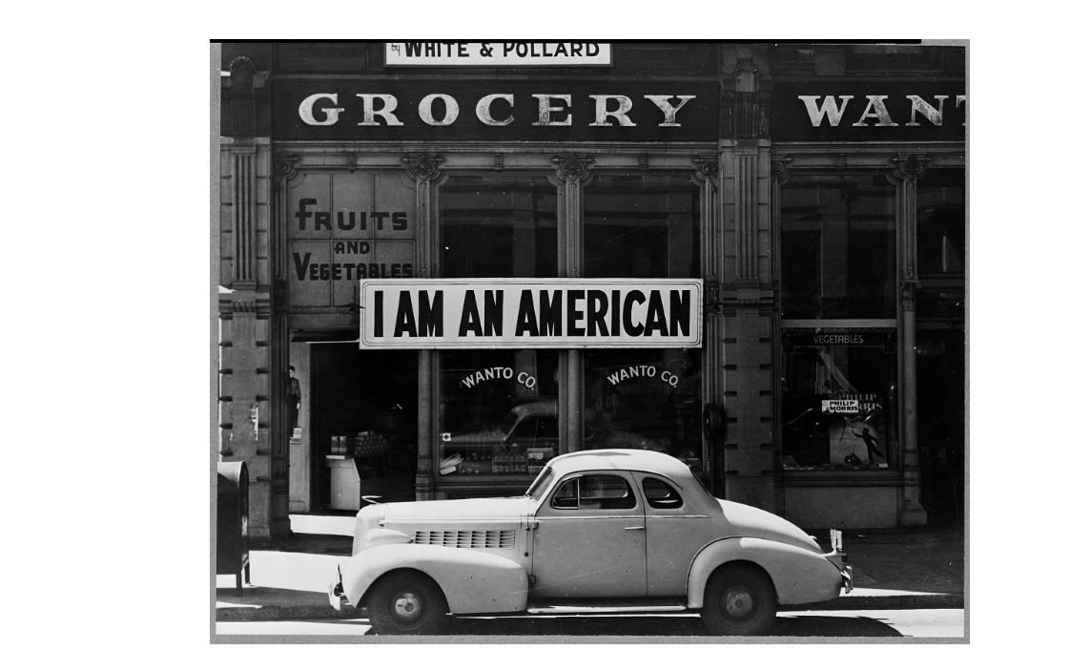

**Source Information:**

The photography was taken by Dorthea Lange while working for the War Relocation Authority in March of 1942. The photograph shows the Wanto Co. store located in Oakland, California. The business was owned by the Matsuda family. It was placed in the window of the store, on December 8, the day after Pearl Harbor. Their store was closed following orders to persons of Japanese descent to evacuate from certain West Coast areas.

|  |
| --- |
| 1. **What are the likely reasons that the Matsuda family put this sign up in front of their store? How might those reasons be related to the timing of when they put it up?** 2. **Consider ideas around racism, loyalty, citizenship, and civil rights. What is the larger message that “I am an American” might convey to those who see the sign?** |

**Document 2: “Japanese Relocation” a government produced short film.**

**Source Information:**

“Japanese Relocation” was a film produced in 1943 by the U.S. Office of War Information, the film "Japanese Relocation" addressing the internment of Japanese American citizens during World War II.

[**Click here to view the film.**](https://www.youtube.com/watch?v=yVyIa11ZtAE&t=320s)

|  |
| --- |
| 1. **Considering the origin and contents of the film, what is the purpose of the film?** 2. **What is the “story” or Japanese Incarceration the film tries to tell? How does the images and music contribute to that message?** 3. **Why would it be a bad idea for a historian to use this film as evidence for what Japanese Incarceration was like?** 4. **What value would this film have for a historian? How should a video like this be used to help understand what happened?** |

**Document 3: “Americans in Concentration Camps” Editorial**

**Source Information:**

The following excerpt is from an editorial titled “Americans in Concentration Camps,” written by Harry Paxton Howard in September 1942. It was published in *The Crisis* shortly after the establishment of incarceration camps for Japanese Americans. Founded in 1910, *The Crisis* is the official magazine of the National Association for the Advancement of Colored People (NAACP), an organization dedicated to promoting civil rights.

Along the eastern coast of the United States, where the numbers of Americans of Japanese ancestry is comparatively small, no concentration camps have been established. From a military point of view, the only danger on this coast is from Germany and Italy. . . . But the American government has not taken any such high-handed action against Germans and Italians – and their American-born descendants – on the East Coast, as has been taken against Japanese and their American-born descendants on the West Coast. Germans and Italians are “white.” Color seems to be the only possible reason why thousands of American citizens of Japanese ancestry are in concentration camps. Anyway, there are no Italian-American, or German-American citizens in such camps.

|  |
| --- |
| 1. **Does the author support the need for camps on the basis of national security? Use evidence from the text to support your response.** 2. **What is the reason that the author suggests is the reason why there were camps for people of Japanese descent, but not for people of German or Italian descent?** |