**HUMANITIES CONNECTIONS TO LITERATURE**

|  |
| --- |
| **HUMAITIONS CONNECTION ASSIGNMENT PART 3**  *They Called us the Enemy* focuses on a chapter of history where people of Japanese descent were unjustly treated by the United States in government. While fears created by war set things in motion, racial prejudice was a larger driving factor behind the discrimination people faced at the hands of their communities and governments. Discrimination against Asian American community during the current pandemic has demonstrated that this is still an ongoing issue.  The article below was written in April 2020, near the beginning of the pandemic. The increase in discrimination and hate crimes against the Asian American community has continued since that point, including the death of eight people that occurred last March in Atlanta, GA. As you read the article, think about how events of the past are still connected to the presents and the importance of learning from the mistakes of the past. |

**What it's like to be Asian during the Coronavirus Pandemic**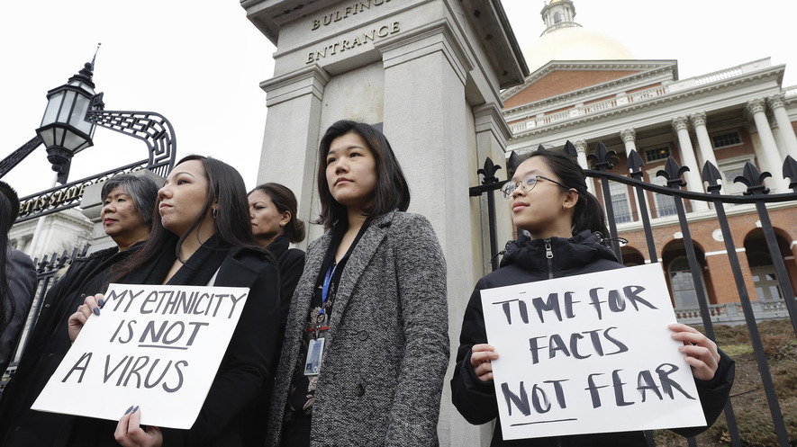

Jessica Wong (front left), Jenny Chiang (center) and Sheila Vo (right) from the Massachusetts Asian American Commission protest racism aimed at Asian American communities across the United States amid the coronavirus pandemic on March 12, 2020, in Boston, Massachusetts. Photo: Steven Senne/AP Photo

Carl Chan was shopping in San Francisco, California. He covered his mouth to cough a little. A couple standing about 20 to 30 feet away from him stared in alarm. Then the woman turned and ran away.

Another time, he was walking down a street in Oakland, California. He was in a group of people when someone started coughing. It wasn't Chan, but people turned around, glared at him and covered their mouths.

The dirty looks happened in early March. It was before California Governor Gavin Newsom ordered the state's 40 million people to stay at home. It was before the coronavirus killed thousands of Americans and infected thousands more.

During the pandemic, Asian Americans across the U.S. have become the target of xenophobic and prejudiced attacks. Xenophobia is the fear and dislike of people from foreign countries. Experts said the scapegoating is fueled by harmful speech from politicians. Experts said this includes President Donald Trump. He later called for the protection of Asian Americans from xenophobic attacks after repeatedly calling COVID-19 the "Chinese virus." On March 23 he posted a message online. Trump called Asian Americans "amazing people." He said the epidemic is "NOT their fault in any way, shape or form."

|  |
| --- |
| 1. **What is driving the current wave of prejudice and discrimination experienced by Asian Americans?** |

**Asian Americans Yelled At, Even Physically Assaulted**

Russell Jeung works for San Francisco State University in California. He leads the Asian American Studies Department. He's been studying harmful incidents against Asian Americans during the pandemic. Jeung said that in recent months, people from all Asian backgrounds have been mistreated. It is not just Chinese Americans. People have been yelled at, coughed and spat on and even physically attacked, he said.

Face masks are often worn in Asian countries for cultural and environmental reasons. The practice has crossed over to Asian communities in the United States. Now masks are a racial symbol of the virus.

Jeung gave an example. If Asian Americans wear masks, they are seen as disease carriers. If they do not wear masks, they are seen as disease carriers who are acting careless, he said.

There are many stories of harassment reported in the media and by groups that fight against discrimination. Many police departments have not seen a change, though. They said they have not seen a large rise in the number of hate-crime reports related to COVID-19. This suggests that people might have doubts or fears about reporting these incidents to the police.

**Concerned That Incidents Are Not Being Reported**

Steve Mylett is the police chief in Bellevue, Washington. He is concerned that incidents are not being reported. He said that hate crimes normally start as verbal attacks. Then they escalate into physical violence. It is important for law enforcement to get involved early, before the situation becomes more dangerous, he said.

Jeung, the San Francisco State professor, said there are several reasons why people might not want to report to police. Many Asian Americans are cautious about dealing with the government, he said. Some left their home countries to escape authoritarian governments. One ruler or a small group of leaders has the real power in authoritarian political systems. Authoritarian governments might hold elections and they might have contact with their citizens. However, citizens do not have any voice in how they are ruled. Their leaders do not give their subjects free choice. Instead, they decide what the people can or cannot have.

Some people who have been targeted came to the United States without permission and are fearful of calling attention to themselves. Speaking different languages can also be an issue.

Jeung recently teamed up with two groups in California that fight against discrimination. They launched a website. It allows people to report incidents without including their names. They received 673 responses in one week from across the country.

|  |
| --- |
| 1. **Why are incidents not being regularly reported to the police?** |

**Chinese Americans Not The Only Targets**

The incidents did not only involve Chinese Americans. They involved Japanese, Koreans, Taiwanese, Vietnamese and Filipinos. This highlights that Asian Americans from many backgrounds are facing unfair treatment, Jeung said.

Some reported being coughed at and spat on. Some said they were yelled at in stores by workers and customers, who blamed them for bringing the virus to the country. Some said drivers from companies like Uber and Lyft refused to give them rides.

In Oakland's Chinatown, the unfair treatment has hurt business, said Chan. Family businesses began losing money. Many of them were started years ago by people who came to the United States for a better future for their families.

"Personally, I feel very sad … When I'm quietly sitting down, I just feel so sad," Chan said. "Many of us are really suffering."

|  |
| --- |
| 1. **What role does fear play in both the discrimination experienced by the Asian American communities today and They Called Us the Enemy? What other elements are common between the two time periods?** |