**Extended Essay: Rising Seniors**

**Close Reading and Examination of Criteria B and C**

**Activity: For the summer assignment, seniors will engage in a source evaluation and use. This exercise is designed to support students’ own work in the EE Criteria B and C.**

Instructions: Please read the following excerpts concerning criteria B and C from the Extended Essay Examiners. Then work through the questions below.

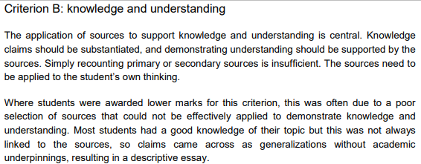

1. **Please summarize what you learn here about sources and your “knowledge claims” within the paper.**

____________________________________________________________________________________________________________________________________________________________________________________________________________________________________________________________________________________________________________________________________________________

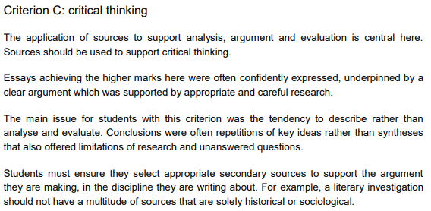

1. **Please summarize here what you learn about sources and their use.**

**__________________________________________________________________________________________________________________________________________________________________________________________________________________________________________________________________________________________________________________________________________________________________________________________________________________________**

**Summer Assignment:**

1. Locate two new sources for your EE which include knowledge that you can cite and apply to the evidence you have compiled within your own EE draft thus far. Add this new source material to your EE work. Bring your EE to reflect on appropriately with your EE mentor when you return from summer break. Be prepared to defend your sources and explain your application and analysis of their work to your own EE work. Your adviser will review the Criteria B and C with you this fall.

**Sample for a history paper:**

|  |  |  |
| --- | --- | --- |
| **Source** | **Knowledge** | **Application of Knowledge to a Paper** |
| Krippendorff, K. (2004) Content Analysis An Introduction to its Methodology. Sage Publications. Thousand Oaks, CA. | Krippendorff (2004) identifies six steps to use when analyzing a written text. These six steps are: unitizing, sampling, coding the text, inferring information, and narrating an answer. | **I applied** Krippendorff (2004) to my newspaper text evidence. I followed the steps he laid out.  *(**Directly explain all six steps from Krippendorff (2004) and tell your reader the way you applied them and what you found.)* |

My topic:

____________________________________________________________________________________________________________________________________________________________________

New Source 1 : ______________________________________________________________________________________________________________________________________________________________________________________________________________________________________________________

New Source 2:

______________________________________________________________________________________________________________________________________________________________________________________________________________________________________________________

Rubric for Criteria C and B:

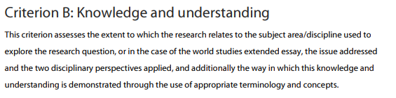

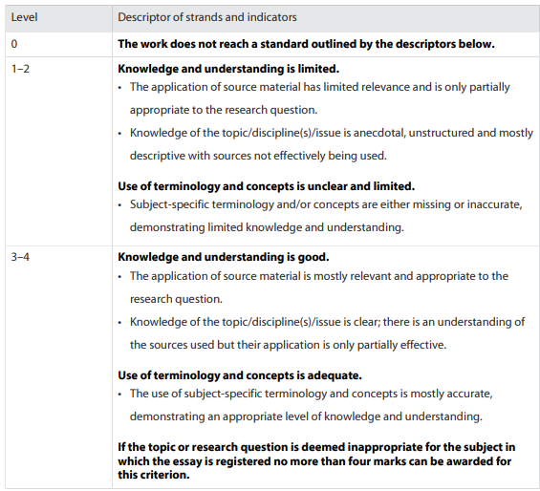

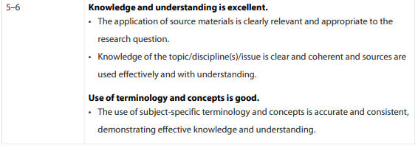

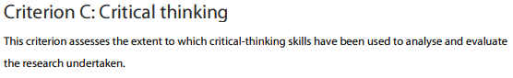

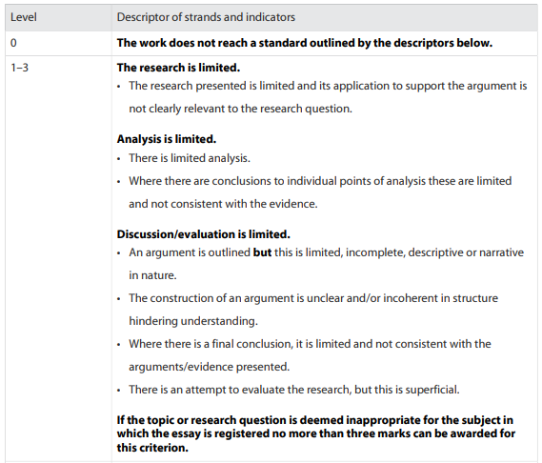



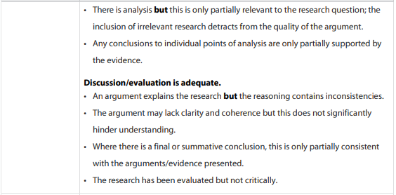

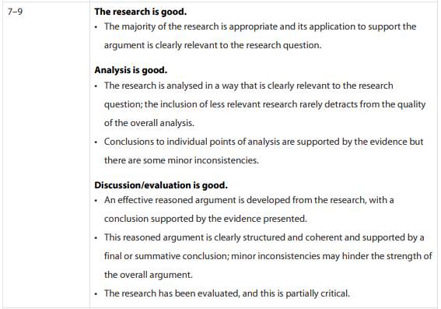

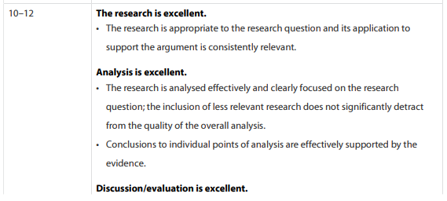

Advisors: Please assess your student’s completion of the summer activity using the EE criteria B and C with total possible points of (6 + 12) 18.

Total Points __________________ / 18