**HUMANITIES CONNECTIONS TO LITERATURE**

|  |
| --- |
| **HUMANITIES ASSIGNMENT PART 2**  In Humanities classes, we try to understand the world and its people. A big part of that includes the study of culture. Culture looks at the”way of life” for a group of people, including the things they do or believe. Some traits of culture are easy to identify, such as how people in a culture like to dress, or to eat, or what language they speak. Some traits of culture are harder to identify, such as what they believe is important or what they find funny. It can be challenging to fully understand your own culture because culture tells you what you think is “normal”, but what is normal to you, might not be normal to people in another culture. We are often part of many different groups and each group might have its own culture. You will learn a lot more about culture this year!  It is important to understand and appreciate the cultures of others. One way that we can learn about different cultures is through books we read. Authors often share parts of their own culture when they write. *Lowriders in Space* is a great example of this. The book shares a lot about the culture of parts of the Mexican American community, especially those who love lowriders! This assignment is designed to help you learn more about the history and culture of lowriders. Here are two things to think about as do this assignment:   * How does understanding more about the history and culture of lowriders make you appreciate *Lowriders in Space*? * How does understanding other cultures connect to learning to respect and value other people? |

**"Low and Slow": Latino Lowriders Artfully Cruise for Community.**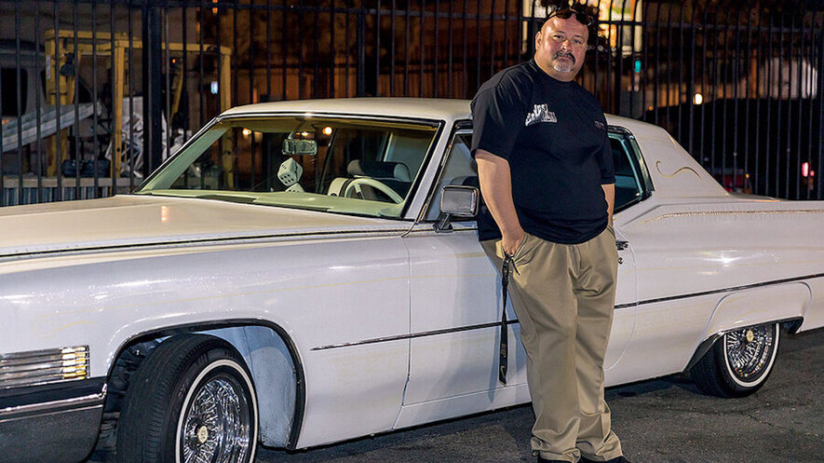

Juan Ramirez stands with his 1970 Cadillac Coupe deVille named Sugar in Downey, California, on November 18, 2020. For Ramirez, lowriding is about "la familia" and showing "my kids I was doing something good — a small little legacy I can give them."

Juan Ramirez helped start the Los Angeles Lowrider Community (LALC). A lowrider is a person who drives a lowrider car, which is a vehicle that has been customized to have its body hang just above the ground.

Ramirez calls his car, a long, white 1970 Cadillac Coupe deVille, "Sugar." By day, Ramirez works as a welder in Los Angeles, California. By night, he cruises Whittier Boulevard in East Los Angeles with his wife and three kids.

Community is a key part of lowrider culture. And Whittier is the backbone of that community. The lowriders, shop owners and neighborhood members all have a respect for one another that goes back decades.

"My kids joke about stealing the car when I'm sleeping," Ramirez said. Their teasing shows they recognize the significance of their dad's car.

Johnny Torres is another member of LALC. He describes driving a lowrider car as if "you're driving on artwork, so you want to be delicate." He drives a baby blue '54 Chevy.

## **More Than Tricked-Out Cars**

Ramirez first sat in a lowrider as a little boy. It was '64 Chevy Impala. He quickly learned that "getting into a nice car – you had to be very proper."

Respect – for property and for others – is a central belief in the lowrider community. It's one of the reasons why in October 2019, Ramirez started the LALC. It's an association of lowrider car clubs in Los Angeles and nearby cities.For LALC members, lowriding isn't just a commitment to a cool car; it's a commitment to the well-being of the community.

## **Lowriders And Chicano History**

"A true lowrider rides from the heart. It's about family, respect and community," says Denise Sandoval. She's a professor of Chicana and Chicano studies at California State University, Northridge. Sandoval curated two exhibitions about lowrider culture for the Petersen Automotive Museum in Los Angeles.

LALC member Edward Villa began hosting car shows for his hometown, La Puente, California, 15 years ago. He wanted to bring Latino heritage to the city's car show. It featured hot rods and other classic cars, but few lowriders. He was motivated by the desire to educate the broader culture about the lowrider community and Chicano culture. The shows he helped to curate grew from about 40 cars to hundreds of cars.

Villa's and other members' altruism is motivated by their commitment to the community. They also want to dispel myths about lowriders. "I want the different cities to realize that we're positive. We're just trying to bring the love for the cars," Villa said. "We just want to show that we have a lot of love for our community."

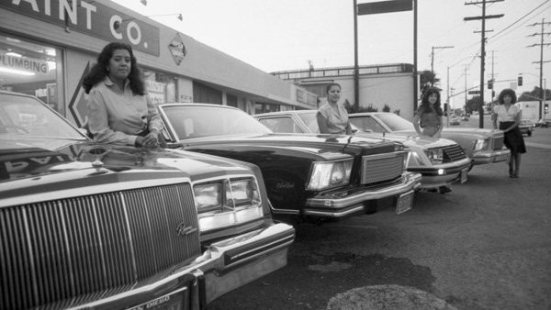

In the 70’s and 80’s women started to make their own clubs. Ladies Pride was one of the first all-women’s car clubs in San Diego.

## **A History Of Social Justice**

Sandoval notes that community activism within the lowrider culture dates back to the 1960s. She says that during the civil rights movement, "Lowriders were empowered to take pride in their community, fighting for social justice and using their culture not just to represent positivity, but to give back."

She credits the Dukes – LA's oldest car club, which started in 1962 – for being the first car club to embrace community activism. Members organized car shows that benefited Cesar Chavez, leader of the United Farm Workers movement, which worked to improve the conditions of agricultural workers and other laborers.

Sandoval said that so much of this history is unknown. She says lowriding emerged from the hot rod culture established in the 1930s and 1940s in Southern California. "Hot-rodders" preferred to ride fast and loud. Meanwhile, lowriders – who emerged shortly after – preferred to drive "low and slow," so they could be seen sporting nice cars and brown skin. It was important to be seen representing their families and neighborhoods.

This pride in culture, car and community is on display most weekends on Whittier Boulevard and throughout Los Angeles. The boulevard is the venue and the neighborhood is the crowd. The cars and their drivers are the main attractions.

LALC's goal is to continue to host events that highlight and boost the larger community. "We're not going to stop," Torres said. "We're going to take this culture into schools, into museums, into the mainstream."

Ramirez hopes his children preserve the lowriding lifestyle and tradition when they're old enough to drive. For him, it's all about la familia. Lowriding, he said, "is the only thing I can do to show my kids I was doing something good – a small little legacy I can give them."

|  |
| --- |
| 1. **What are some of the reasons that the Los Angeles Lowrider Community (LALC) was started?** 2. **Why do you think it is important to Juan Ramirez to pass on lowriding traditions to his children?** 3. **What are some of the traditions that have passed down to you from your parents of other family members?** 4. **Some lowriders have artwork that represents important symbols from Chicanx culture or history. Imagine you had your own lowrider. What are some images or symbols you might put on your car that would represent you?** |

**“Low & Slow: Culture on the Border” Video**

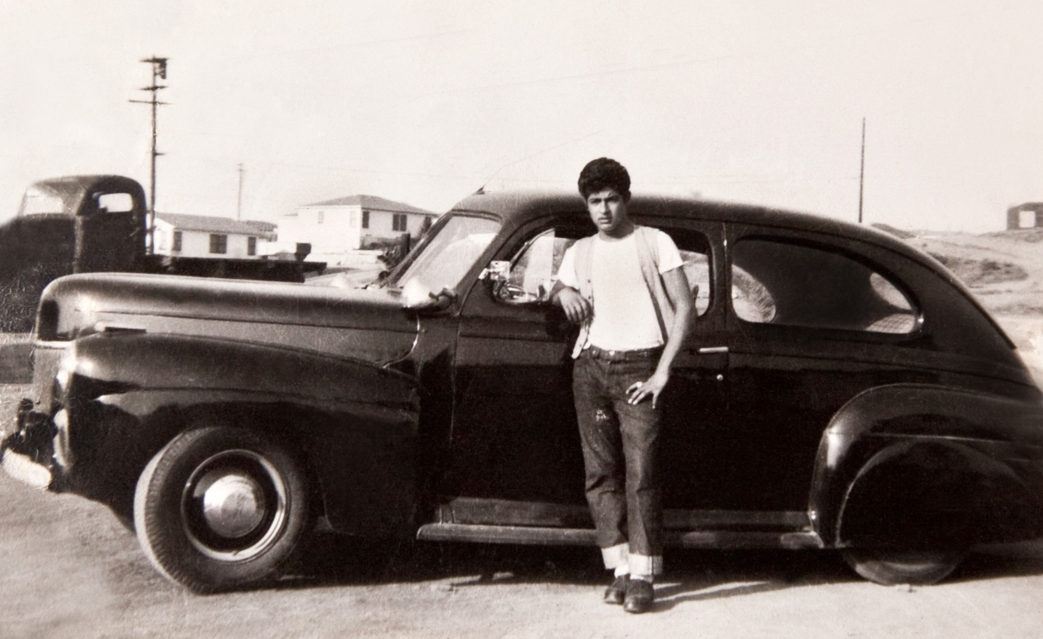

Watch this video created by the El Paso Museum of History as part of their exhibit on the history and culture of lowriding. It has more information about the history and culture of lowriding.

[**Access the Video Here**](https://www.youtube.com/watch?v=bwM3xjxwKCM)

|  |
| --- |
| 1. **What are three interesting facts or ideas that you learned from the video?**    1. **(Fact 1)**    2. **(Fact 2)**    3. **(Fact 3)** |