**ENTRY #1: BRAINSTORMING IDEAS**

In your 10th grade project-based research class, you will complete what is called the personal project. This is a yearlong project through which you can further explore an area of personal interest. Therefore, brainstorm topics for your personal project by answering the following questions within the mind map bubbles in 1-5 words. You must choose a topic that is of personal interest (why you want to do this project) and can be a:

* Value
* Hobby
* Curiosity
* Family passion
* Social issue
* Cultural element

**ENTRY #2: BRAINSTORMING GOALS/PRODUCTS**

Now that you have brainstormed general ideas for the personal project, you can brainstorm more specific ideas for the two main yet interrelated parts of the personal project: the learning goal and product. The learning goal is what you want to learn whereas the product is what you want to create. You can start your project with either the learning goal or the product. One learning goal can lead to different products, just as one product can relate to a variety of learning goals (see example below). Therefore, brainstorm several learning goals and products for your potential personal project by filling in the boxes below with examples of both.

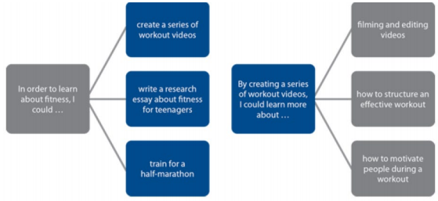

**LEARNING GOAL**

**PRODUCT #2**

**PRODUCT #3**

**PRODUCT**

**PRODUCT #1**

**LEARNING GOAL #3**

**LEARNING GOAL #2**

**LEARNING GOAL #1**